RED LODGE TRANSITION SERVICES
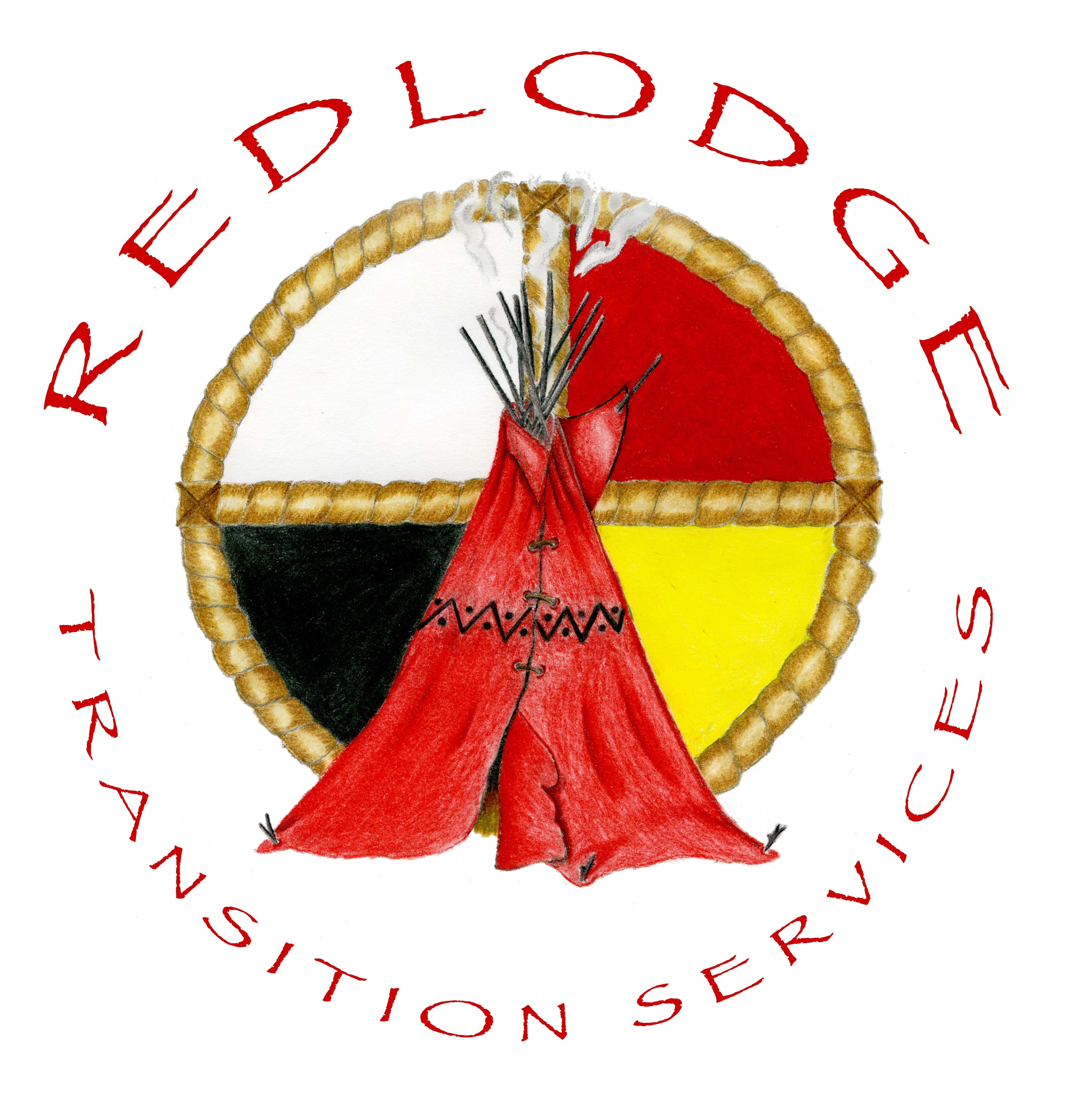
MISSION STATEMENT

MISSION
To prevent incarceration and reduce recidivism primarily among Native American women and men. To provide assistance for individuals released from jails and prisons, who are working on creating a better life for themselves, their children, and communities. To supply transition information, guidance and support, to Native American individuals, families and communities. To prevent and reduce incarceration by breaking the cycle of chemical addiction, violence, abuse, hatred, hopelessness and neglect.
VISION
To create positive change by educating the public, communities, social service providers, and Department of Corrections on the importance of providing culturally competent programming to Native Americans. To develop and implement culturally competent pre and post incarceration programs which will aid in prevention, increase responsibility, respect and empowerment of individuals, families and communities.
VALUES
We believe in promoting healthy choices, modeling healthy lifestyles, and encouraging positive attitudes. We believe in maintaining a non judgmental approach toward people’s circumstances, history and/or conviction. We hold ourselves and others accountable. We believe people can and do change, and that all people are capable of greatness, given the proper tools and opportunities. We believe all life is sacred.

